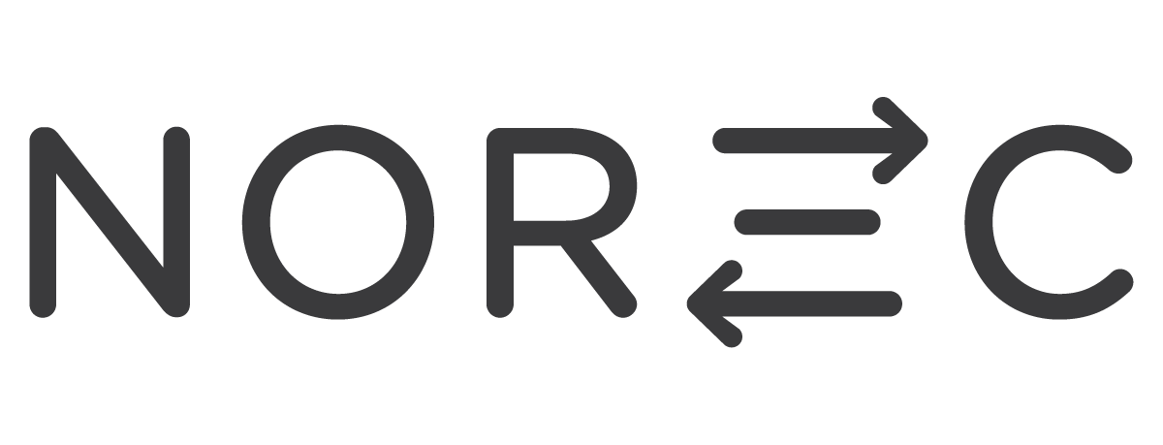

Application form for Solidarity Exchange for the Environment and Development (SEED)
Practical information
First name:
Last name (As written in passport):
Date of birth (DD/MM/YYYY):
Nationality:
E-mail address:
Phone number:
Are you or have you been active in Spire? (Yes or No. If yes, how/where):
Tell us a little bit about yourself! Who are you and what is your motivation for going on this solidarity exchange?

What kind of experience do you have that you think would be valuable in this project?

Which of the topics for the exchange (climate justice, agriculture, and development in relation to youth, sustainability, and gender equality) are you interested in? Do you have any qualifications or valuable experiences in any of these areas?

Do you have any organisational experience that will be relevant in this solidarity exchange?

What personal qualities do you have that you think will be useful during the exchange?

After the exchange period you will join a committee during the spring semester to do follow up work in Spire. Do you have time and motivation to do this, will you stay in Oslo during this period, and do you have any ideas in what way you would like to use what you have learned?

What do you think will be the greatest challenges during the solidarity exchange? Both personal and professional and how will you deal with these challenges?

Do you have any travelling experiences or experiences with living abroad for a longer period?

If you are chosen to be a participant in this exchange, what do you think it will be like?

Do you have any additional comments or relevant information as to why you will be a good participant in the project?

